JazzNights (92)

For some years, Jazz at the Kitano devoted Tuesday evenings to mostly solo gigs featuring young pianists. I liked those evenings very much. [The policy has changed, alas – Gino – bring it back!] They were quite informal, low pressure (at least for the audience) hangs, and the “young pianists” were almost uniformly super. They were a fine counter to the notion that jazz has passed its peak, reaffirming that the talent pool is very deep and that there are young people aplenty coming up. One of the very best of them was Addison Frei.

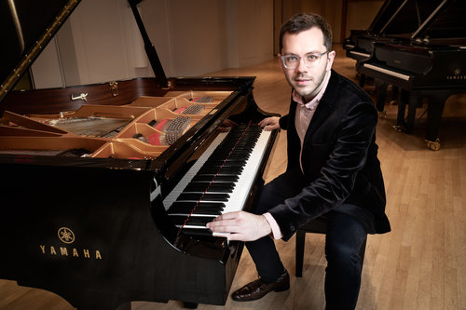

I met Addison Frei during one of those Tuesday nights, and returned as often as I could when he was there. He is comfortable with jazz and songbook standards, classically–influenced material, and his own compositions. He began playing at 10, was musically educated at the renowned North Texas Jazz Studies Program, from which he received the Outstanding Undergraduate Jazz Studies Student Award, and graduated summa cum laude. He plays with skill, feeling, and always has a great rapport with his audience. He’s won the 2017 Parmigiani Montreux Jazz Piano Solo Competition, the 2016 UNISA International Jazz Piano Competition in Pretoria, South Africa, the 2015 American Jazz Pianist Competition in Melbourne, Florida, and the 2012 Jacksonville Jazz Piano Competition. He’s also a composer of note, a two-time recipient of the Herb Alpert Young Jazz Composers Award. Not bad. Mr. Frei is no longer up and coming, he’s arrived.

He brings with him two other young stars, bassist Elias Bailey and drummer Curtis Nowosad. Mr. Bailey is singer Rene Marie’s (JazzNights 7) bassist and has played with such luminaries as Steve Wilson, the great vocal trio “Dutchess,” and Larry Willis. Curtis Nowosad comes from Winnipeg, but has “graduated” to New York and the world jazz scene. He, too has awards aplenty, and a very well received 2015 CD – Dialectics Downbeat 4 ½ stars).

Three Addison Frei Cds:

Intentions, Armored Records, ARCD8041, 2014

Transit, Armored Records, ARC8055, 2016

No Defense, Challenge Records, TCB 35502, 2018

"Piano trios are numerous on the musical jazz range, but the Addison Frei Trio is one of the top segments and is therefore a definite must!"

Rootstime

